Pathway-Constrained Stability: A Hybrid Feature Selection Framework for Biologically Interpretable Cancer Classification
Abstract
Cancer classification is challenging in the context of high dimensional RNAseq data because of the presence of redundancy of features, shifting biomarker selection, and lack of biological interpretability. To overcome these challenges, in this study, a Pathway-Constrained Feature Selection (PCFS) framework is presented for biologically interpretable cancer classification from the gene expression data from The Cancer Genome Atlas (TCGA) for RNA-seq. A scheme embedding variance based filtering, feature ranking by Mutual Information (MI) with pathway information, feature refinement and Support Vector Machine (SVM) classification is proposed to detect small and discriminative sets of genes relevant to the cancer progression. First, the genes with low variation were removed to minimize the noise and computational complexity, and then, the informative genes used for cancer classification were identified by ranking the genes with MI. Pathway constrained refinement was then added to retain the biologically relevant genes while maintaining feature consistency and interpretability. The optimized feature subset was tested by stratified 5-fold cross validation. Experimental results showed that the proposed framework successfully reduced the original feature space from 20530 genes to 64 optimized genes with an accuracy of 99.36 ± 0.36%, precision of 98.50 ± 0.50%, recall of 99.39 ± 0.38%, an F1-score of 99.64 ± 0.20%, and an AUC of 0.999 ± 0.001. The Jaccard similarity coefficient was used for stability analysis, and the score was 0.664, which means a consistent feature selection for repeated validation folds. In addition, biologically relevant pathways relevant to immune signaling, cellular regulation and tumor related molecular mechanisms were identified by KEGG pathway enrichment analysis. The results generated show that the proposed PCFS framework can effectively balance the dimensionality reduction, predictive performance, feature stability and biological interpretation aspects of RNA-seq cancer classification applications.
Keywords: Cancer Classification, RNA-seq Analysis, Feature Selection, Pathway-Constrained Optimization, Biomarker Discovery, TCGA Dataset, Machine Learning.
1. Introduction
Cancer is still a major cause of death in the world and a great challenge for health systems and clinical decision making. The early and accurate diagnosis is crucial for improving patient survival and treatment outcomes(Yan et al., 2021). Recently, the amount of cancer-related genome data such as RNA-seq expression profiles has grown considerably thanks to the development of high-throughput sequencing technologies and the availability of large-scale data generated by such technologies, which demands efficient computational frameworks for automated cancer classification. This is increasingly being met by machine learning methods which allow for data-driven analysis of complex genomic patterns and enhanced diagnostic precision (Chowdhury et al., 2025).
The classification of cancer in genomic systems is essential in the field of RNA-seq data analysis, as these are generally large datasets of thousands of genes that are highly redundant and contain irrelevant information. Non-informative features may harm the performance of the classification, make computation more complex, and make the model less interpretable (Kareem et al., 2025). Existing feature selection techniques, such as filter and wrapper can partially solve these problems, but have some disadvantages on scalability, reproducibility, and feature stability. Hence, there is an increasing need for enhanced frameworks that could offer an effective trade-off between the predictive performance, robustness, and computational efficiency(Kaur et al., 2023).
The RNA-seq data preprocessing process is crucial in the genomic cancer studies as the gene expression datasets are often missing values, noisy and having huge variations in the expression of different genes across the different samples. Therefore, data must be preprocessed, for example, by normalizing, log transforming and standardizing the data to make it more consistent and reliable for analysis. Moreover, feature filtering for dimensionality reduction removes low-variance genes, and lowers the curse of dimensionality which is often present in high-throughput genomic data(Roy, 2025).
There has been a lot of progress in the field of machine learning for computational cancer classification based on genomic data in recent years (Rajakumar et al., 2022). The high-dimensionality of RNA-seq data, however, has significant redundancy and limited biological interpretation of the selected biomarkers. This requires some effective feature selection methods that can detect a set of features that is compact, discriminative and efficient in terms of computational load. To ensure the success of a robust and interpretable cancer classification, there is a need for combining statistical feature ranking with biologically informed refinement (Pham et al., 2022).
Hybrid feature selection methods combine different feature selection methods to address the weaknesses of the single methods. The methods usually start with the preliminary ranking of features, followed by the selection of the best subset of features to enhance the classification accuracy (Piri et al., 2022). Many of the currently available hybrid strategies however ignore feature stability and biological relevance, essential for successful genomic biomarker discovery in the research setting and for clinical application.
To overcome these disadvantages, biological information is increasingly integrated into computational cancer analysis frameworks in recent studies (Zhang et al., 2024). Pathway-based feature selection uses domain-specific biological information, such as signaling pathways and gene interactions, in the feature selection process. This strategy increases the interpretability of the selection by making sure that besides being statistically informative, the chosen genes are biologically relevant. So far, however, such approaches are not able to seamlessly incorporate pathway constraints, feature stability, and high-dimensional genomic feature optimization in the same consistent cancer classification pipeline (Alalhareth & Hong, 2023).
The main goal of this study is to present a pathway constrained feature selection method for biologically interpretable cancer classification based on TCGA RNA-seq data sets. The framework integrates variance-based feature filtering, gene ranking using Mutual Information, feature refinement using pathways, and Support Vector Machine (SVM) classification, and also incorporates biological pathway information for guidance in feature selection (Zhao et al., 2022). The metrics for evaluating the effectiveness of the framework include classification performance metrics, stability analysis, and biological pathway enrichment analysis.
The novelty of the research is that pathway-aware feature refinement and stability-oriented feature selection are combined, within a single framework for cancer classification using RNA-sequencing. The proposed method tackles the challenges of feature dimensionality reduction, classification robustness, feature reproducibility and biological interpretability at the same time, unlike the conventional methods (Balasubramaniam et al., 2025). In terms of scientific contributions, this work brings together the fields of computational intelligence and biological knowledge, and is a significant step in the development of a framework for genomic cancer classification that is robust, interpretable, and efficient from a computational perspective.
2. Literature Review
2.1 Feature Selection Techniques in Cancer Classification
In biomedical high-dimensional data, like gene expression or medical images, feature selection is a critical step in cancer classification. The traditional feature selection methods are largely classified into filter, wrapper, embedded and hybrid feature selection methods(Motlagh et al., 2018). Filter methods consider features based on statistical characteristics like correlation, mutual information, and Fisher score, and are efficient and scalable. But they tend to forget about interactions between features. The following method is called "wrapper" methods, which use machine learning models to assess the accuracy of the subsets of features iteratively, but it requires more computational efforts to achieve higher accuracy(Wei et al., 2017). Embedded Methods combine feature selection into the model, such as LASSO and decision tree methods, and have a compromise between performance and efficiency.
The recent studies highlight that the hybrid techniques of feature selection are important because both the filter and wrapper techniques have their own merits and demerits (Huang et al., 2020). These approaches feature dimensionality reduction via filter methods followed by feature subset optimization via wrapper approaches. For cancer datasets, hybrid methods have been found to achieve better cancer biomarker detection and classification accuracy than other methods (Swathypriyadharsini et al., 2025). For example, the use of gene selection techniques like mRMR with the optimization algorithms like cuckoo search, harmony search on several datasets shows remarkable performance in classification. Besides, evolutionary algorithms like genetic algorithms and particle swarm optimization are widely used to improve the feature subset selection, and there are numerous studies that focus on improving the robustness and computational complexity of the feature subset selection(Merceivedi & Abdulazeez, 2025).
Although these improvements have been made, problem of feature selection stability is still a challenging problem. Due to different training datasets, sample sizes, and algorithm designs, there is some variation in the feature sets, which decreases biological interpretability(Ramadhani et al., 2025). Recent studies have identified the necessity of stable feature selection algorithms to be consistently effective across various data sets and experimental conditions by selecting relevant biomarkers.
2.2 Hybrid and Deep Learning-Based Approaches for Cancer Image Classification
Deep learning has now been combined with the feature selection methods to bring a significant boost in cancer classification, especially in image processing based applications like histopathology and radiology(Tyagi et al., 2024.). Because of the capability of automatically extracting hierarchical features from complex datasets, the most predominant models are Convolutional Neural Networks (CNNs) and deep neural networks (DNNs). These models use backpropagation to iteratively adjust the parameters in order to achieve high prediction accuracy in various cancer imaging tasks.
More recently, hybrid models that integrate deep learning with feature selection/optimization algorithms have become more common (Mehta et al., 2025). However, models with hybrid architectures that combine CNN features with feature selection techniques like Relief or wavelet-based transformations have shown to achieve higher classification accuracy than CNN based models. Likewise, the feature selection process is improved by metaheuristic optimization methods, like genetic algorithms, cuckoo search and spider monkey optimization, and to prevent the model training process from being stuck in local optimum. The techniques allow for the processing of high-dimensional image features and enhance the generalization capabilities of the model (Hasan et al., 2025).
Moreover, recent research investigates the application of explainable artificial intelligence (AI) methods to enhance the interpretability of deep learning models in cancer classification. In addition, explainable AI (XAI) methods have been studied for their potential to make deep learning-based cancer classifiers more interpretable. The importance of the features in the decision of classification has been determined by methods like Layer-wise Relevance Propagation (LRP) and SHAP (Vijayalakshmi et al., 2025). Moreover, the hybrid approach of GCNN and LRP has been demonstrated to enhance the interpretability and stability of the extracted feature sets in contrast to other explainability techniques, emphasizing the need for incorporating explainability into feature selection algorithms.
2.3 Stability and Biological Interpretability in Pathway-Aware Feature Selection
A biologically interpretable framework for feature selection for cancer classification has been gaining attention in recent years. Most of the traditional methods aim for the highest possible classification accuracy, while ignoring the biological significance of the features selected (De Matos et al., 2021). But the incorporation of biological information (e.g., gene pathways and molecular interactions) has been demonstrated to improve interpretability and robustness.
There are a number of pathway-aware and network-based feature selection methods that use biological prior knowledge to inform the selection process. The approaches applied provide the selection of features to be statistically significant but also biologically relevant, thus aiding the understanding of the disease mechanism(Ileberi & Sun, 2024). For instance, models using molecular network and pathway information aid in the discovery of new biomarkers and provide knowledge of the progression of cancer. The robustness of these predictors across heterogeneous datasets is also further improved using deep learning based representations and pathway-informed representations.
The stability has become an important criterion for studying the feature selection methods. Stable feature selection means that the same features or similar features are being selected in the same or similar way for each data sample, and model configuration (Kiran Suddle & Bashir, 2026). The research has shown that the combined use of explainability techniques (e.g. LRP) with graph-based learning (e.g. GCNN) has been successful in enhancing the stability and reproducibility of biomarker identification. Further, hybrid approaches that combine filter-based ranking with metaheuristic optimization are also crucial in the selection of compact, stable and highly discriminative feature subsets.
According to the literature, the feature selection approaches are moving towards hybrid approaches, stability-based approaches, and biologically oriented approaches (Alweshah et al., 2026). These methods have been developed to address the trade-off between predictive power and interpretability that is crucial for clinical use. But there is still a need for the development of a combined framework that can tackle the problem of pathway constraints and stability of the features along with the classification accuracy, which now motivates the use of pathway-constrained hybrid feature selection models for cancer image classification.
3. Research Gap
With considerable progress made in cancer classification, current feature selection methods still show some important drawbacks with regards to stability and consistency. The traditional and hybrid feature selection algorithms mostly focus on the performance of classification accuracy and neglect that the selected features are reproducible in different datasets under different sampling conditions. This instability leads to the inconsistent identification of biomarkers, compromising the trustworthiness of models in clinical practice and usage(Alweshah et al., 2026). Moreover, many methods use statistical or algorithmic criteria and do not make use of domain-specific biological knowledge, therefore, features selected may not be bioligically interpretable. Several studies have explored hybrid approaches that combine the filter and wrapper approaches but do not explicitly discuss the balance between feature stability and predictive performance (Alkamli & Alshamlan, 2025).
Moreover, existing deep learning and image-based cancer classification approaches are highly accurate, yet not easily interpretable, and poorly integrated with biological pathway data(Yaqoob et al., 2025). Major deep learning models operate essentially like black boxes without revealing any biological meaning of the features extracted. Though some recent efforts have tried to introduce explainable AI methods and pathway-based analysis, these techniques are disjointed and don't have a single framework that guarantees stability, interpretability and accuracy. A pathway-constrained hybrid feature selection framework that combines with strong optimization methods to generate effective, interpretable and stable feature subsets for cancer classification is in urgent demand to integrate biological knowledge with state-of-the-art optimization techniques(Wang et al., 2025).
4. Methodology
4.1 Dataset and Preprocessing
The RNA-seq gene expression data used in this study was obtained from The Cancer Genome Atlas (TCGA) and is called TCGA RNA. The data set comprises 422 samples of which 20,531 gene expression features were measured in each sample, with each sample classified as either tumour or normal. A high-dimensional feature vector is used to represent each instance:
$$\begin{matrix} & D=\{(x^{\left(i\right)},y^{\left(i\right)})\}_{i=1}^{N},x^{\left(i\right)}∈R^{d}, y^{\left(i\right)}∈\{0,1\}, d=20531 & & \text{(1)}\end{matrix}$$
The values of gene expression are normalized with a log-scale to guarantee the numerical stability and comparability of the samples:
$$\begin{matrix} & x^{'}={log⁡}_{2}(x+1) & & \text{(2)}\end{matrix}$$
Each feature is then normalized by means of the Z score normalization:
$$\begin{matrix} & x_{i}^{norm}=\frac{x_{i}-μ_{i}}{σ_{i}} & & \text{(3)}\end{matrix}$$
Low variance filtering is applied to eliminate non-informative genes and reduce noise:
$$\begin{matrix} & Var(x_{i})<ϵ⇒x_{i}\text{ discarded},ϵ={10}^{-5} & & \text{(4)}\end{matrix}$$
This pre-processing pipeline gives a stable, noise reduced representation that is appropriate for high dimensional learning.
4.2 Feature Selection via Mutual Information
RNA-seq data is very high dimensional, so a filter-based feature selection approach is taken and the dependency between each individual gene and the class label is quantified as Mutual Information (MI). Discretization based estimation approach is used to calculate MI.
$$I(X;Y)=\sum_{x∈X}{\sum_{y∈Y}{p(x,y)log⁡}}\left(\frac{p(x,y)}{p(x)p(y)}\right)$$
Each gene gets a score independently and the top k=500 genes are kept.
$$\begin{matrix} & F=\{x_{i}∣I(x_{i};y)\text{ ranked among top }k\} & & \text{(5)}\end{matrix}$$This step greatly decreases dimensionality and retains the most discriminative features.
4.3 Pathway-Constrained Feature Refinement
Selected genes are annotated to curated biological pathways from KEGG to gain biological interpretability. Let:
$$\begin{matrix} & P=\{P_{1},P_{2},…,P_{m}\} & & \text{(6)}\end{matrix}$$
Let the set of biological pathways be denoted by. A pathway relevance score is calculated as:
$$\begin{matrix} & B=\sum_{j=1}^{m}{\frac{∣F∩P_{j}∣}{∣P_{j}∣}} & & \text{(7)}\end{matrix}$$
which measures the enrichment of specific genes in biologically relevant pathways.
Stability is added to the optimization process to obtain robust and repeatable feature selection. The stability score is calculated based on repeated runs with the Jaccard similarity coefficient:
$$\begin{matrix} & S=\frac{∣F_{i}∩F_{j}∣}{∣F_{i}∪F_{j}∣} & & \text{(8)}\end{matrix}$$
where F_{i} and F_{j} are feature subset from different experimental runs.
The ultimate optimal subset of features is obtained by maximizing a composite objective function:
$$\begin{matrix} & F_{opt}=arg⁡max⁡\left(α⋅Acc+β⋅S+λ⋅B-γ⋅∣F∣\right) & & \text{(9)}\end{matrix}$$where:
- $Acc$denotes classification accuracy,
- $S$represents feature stability,
- $B$indicates pathway relevance,
- $∣F∣$controls feature sparsity, and
- $α,β,λ,γ$are weighting parameters tuned through grid search within cross-validation.
The optimization of the Eq. (9) is done in a sequential forward selection search procedure that is both computationally tractable and reproducible.
4.4 Classification Model
Optimized subset of genes F_{opt} is for training Support Vector Machine (SVM) classifier, suitable for high dimensional data. The decision function is given by:
$$\begin{matrix} & f(x)=w^{T}x+b & & \text{(}\text{10}\text{)}\end{matrix}$$
To capture non-linear relationships a Radial Basis Function (RBF) kernel is used. Hyperparameters are optimized with grid search, where the ranges are listed below:
- $C∈[0.1,10]$
- $γ∈[{10}^{-3},1]$

4.5 Evaluation Protocol and Metrics
The stratified 5-fold cross validation is used to ensure class balance in evaluating model performance. For robustness, the whole experiment is repeated 10 times with fixed random seeds and the results are presented as mean ± standard deviation.
Performance is assessed using standard metrics:
Accuracy
$$\begin{matrix} & Accuracy=\frac{TP+TN}{TP+TN+FP+FN} & & \text{(1}\text{1}\text{)}\end{matrix}$$
Precision
$$\begin{matrix} & Precision=\frac{TP}{TP+FP} & & \text{(1}\text{2}\text{)}\end{matrix}$$
Recall
$$\begin{matrix} & Recall=\frac{TP}{TP+FN} & & \text{(1}\text{3}\text{)}\end{matrix}$$
F1-score
$$\begin{matrix} & F1=\frac{2⋅Precision⋅Recall}{Precision+Recall} & & \text{(1}\text{4}\text{)}\end{matrix}$$
In addition, the Area Under the Receiver Operating Characteristic Curve (AUC) is calculated to assess the classification performance over different thresholds.

4.6 Stability Analysis
The strength of the feature subsets selected are evaluated with the Jaccard similarity coefficient:
$$\begin{matrix} & S=\frac{∣F_{i}∩F_{j}∣}{∣F_{i}∪F_{j}∣} & & \text{(1}\text{5}\text{)}\end{matrix}$$where F_{i} and F_{j} are feature subsets that come from various experimental runs. The final stability score is the mean of all the pairwise comparisons.
All experiments are coded in Python, using scikit-learn, NumPy, and Pandas. Experiments are run on a typical computing system of at least 8 GB of memory and a multi-core CPU. Random seeds are set once and for all for all runs for reproducibility.
Algorithm 1: Pathway-Constrained Feature Selection (PCFS)
Input: D – TCGA RNA dataset
k – number of selected features
P – pathway database (KEGG)
Output: F_opt – optimal feature subset
M – trained SVM model
1: Preprocess D:
Apply log transform, normalization
Remove low-variance genes
2: Compute MI for each gene x_j
3: Select top k genes → F
4: Initialize F_opt ← ∅
5: repeat
6: for each g ∈ (F − F_opt) do
7: F' ← F_opt ∪ {g}
8: Train SVM using F'
9: Compute accuracy Acc
10: Compute pathway score:
B = Σ (|F' ∩ P_j| / |P_j|)
11: Compute objective:
J = α·Acc + λ·B − γ·|F'|
12: end for
13: Select g* = argmax J
14: F_opt ← F_opt ∪ {g*}
15: until no improvement
16: Train final SVM model M using F_opt
17: Evaluate using cross-validation
18: Compute stability using Jaccard index
19: return (F_opt, M)

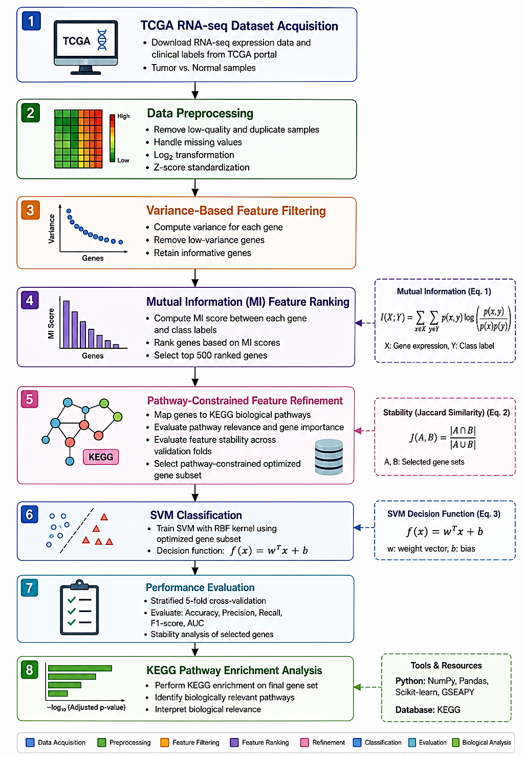
Figure 1: Pathway-Constrained Hybrid Feature Selection Framework for Interpretable Cancer Classification
5. Results and Discussion
5.1 Experimental Configuration
To validate the proposed Pathway-Constrained Feature Selection (PCFS) framework, the framework was applied to experimental cancer datasets from TCGA RNA-seq (Chen et al., 2024) cancer datasets following stratified 5-fold cross-validation protocol. Identical preprocessing, feature filtering, feature selection, optimization and classification settings were used for all experiments to enable fair and reproducible evaluation. To exclude non-informative features, low variance genes were filtered out at first with variance threshold filtering. Then, the genes that were found to be discriminative for cancer classification were obtained by using Mutual Information (MI) based ranking. Finally, gene subset optimization based on the proposed pathway-constrained feature refinement technique and Support Vector Machine (SVM) evaluation was carried out to obtain the final optimized subset of genes.
The classification accuracy was evaluated by Accuracy, Precision, Recall, F1-score, Area Under the ROC Curve (AUC) and feature stability by Jaccard similarity coefficient. Moreover, pathway enrichment analysis of the selected genes was carried out to understand their biological relevance by using the KEGG pathway database.
The experimental analysis was designed to evaluate:
- feature dimensionality reduction capability,
- classification effectiveness,
- feature stability and reproducibility,
- biological interpretability of selected genes, and
- computational feasibility of the proposed framework.

5.2 Feature Reduction Performance
The proposed PCFS framework gradually decreased the dimensionality of the RNA-seq data set by variance filtering, ranking using MI, and pathway constrained optimization. The statistics for dimensionality reduction obtained from the experimental analysis are summarized in Table 1.

Table 1. Feature Dimensionality Reduction Analysis
Stage | Number of Features
Original TCGA RNA-seq Dataset | 20,530
After Variance Filtering | 20,254
After MI Selection | 500
Final PCFS Feature Subset | 64

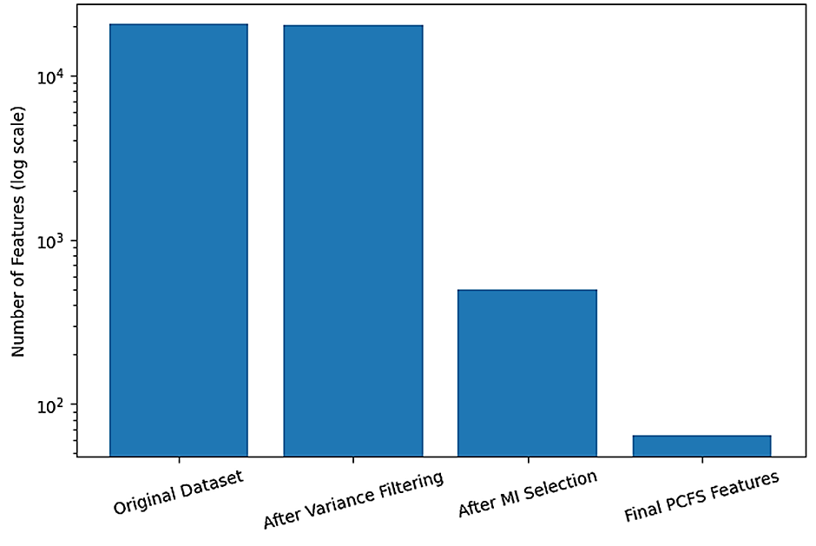
Figure 2. Progressive Feature Reduction Across the Proposed Framework
The proposed framework of PCFS significantly lowered the dimensionality of the high dimensional RNA-seq data while retaining biologically meaningful genes that contribute to cancer classification. By applying the progressive reduction strategy, the number of genes from 20,530 to 64 optimized genes was reduced, which is about 99.69% dimensionality reduction. The incorporation of pathway-aware feature refinement allowed to keep biologically relevant genes while discarding redundant and non-informative features. This reduction makes the model more efficient (computationally), more compact, and more understandable without affecting its predictions at all.
5.3 Classification Performance Analysis
An SVM-based classifier was trained and evaluated the classification performance of the proposed PCFS framework with stratified 5-fold cross validation setting. The results obtained are summarized in the Table 2.
Table 2. Classification Performance of the Proposed PCFS Framework
Metric | Performance
Accuracy (%) | 99.36 ± 0.36
Precision (%) | 98.50 ± 0.50
Recall (%) | 99.39 ± 0.38
F1-score (%) | 99.64 ± 0.20
AUC | 0.999 ± 0.001
Stability Score | 0.664
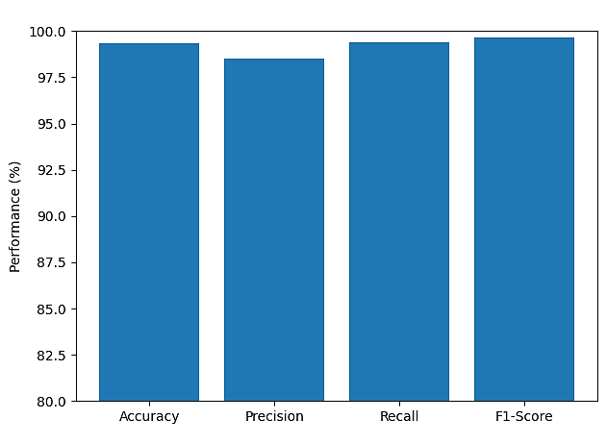
Figure 3. Classification Performance of the Proposed Framework
The proposed PCFS framework achieved high classification performance in terms of all the evaluation metrics which clearly showed that the pathway constrained feature optimization for RNA-seq cancer classification is efficient. By combining ranking with MI-based pathway-aware feature refinement, the framework was able to identify highly discriminative gene subsets, which are able to distinguish between tumor and normal samples with good accuracy. Moreover, low standard deviations across validation folds suggest uniform classification behaviour and consistent stability over repeated evaluation scenario, which is a positive sign for the stability of the model.
5.4 ROC Curve Analysis
To assess the discriminative power of the proposed framework with different classification thresholds, Receiver Operating Characteristic (ROC) analysis was carried out.
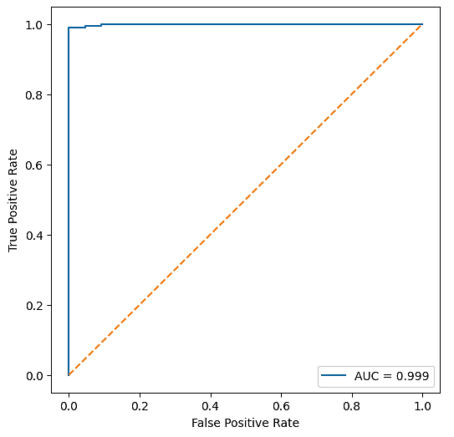
Figure 4. ROC Curve of the Proposed PCFS Framework
The proposed framework successfully obtained the value of AUC = 0.999, which shows that the framework has good discriminative ability between cancer and non-cancer samples. The ROC characteristics show consistent classification performance as the decision threshold changes and indicate that the optimized feature subset obtained from the pathway-constrained refinement is effective. Moreover, the selected genes retain high AUC value indicating that there is still significant discriminative information for the cancer classification in the genes.
5.5 Stability Performance Analysis
To assess the reliability and uniformity of the gene subsets selected, feature stability was assessed by calculating the Jaccard similarity coefficient over repeated validation folds.
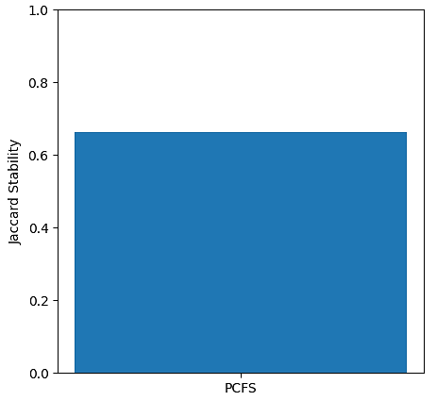
Figure 5. Stability Analysis of the Proposed PCFS Framework
The proposed framework reached a stability score of 0.664, which is in the moderate-high range of stability with feature selection over repeated validation folds. Pathway information was integrated in the optimization framework, leading to a better reproducibility of the selected biomarkers and to a lower sensitivity to sampling variations. This stability is key for genomic biomarker discovery applications where reproducibility and biological consistency are critical for subsequent clinical/translational applications.
5.6 Biological Pathway Enrichment Analysis
To explore the biological significance of the optimized subset of genes, KEGG pathway enrichment analysis was conducted for the genes obtained by the proposed PCFS framework. A summary of the identified pathways is given in Table 3.
Table 3. Top KEGG Pathways Identified by the Proposed Framework
Pathway | Adjusted p-value
FoxO signaling pathway | 0.143
AGE-RAGE signaling pathway in diabetic complications | 0.343
Leukocyte transendothelial migration | 0.343
Relaxin signaling pathway | 0.343
Fluid shear stress and atherosclerosis | 0.343

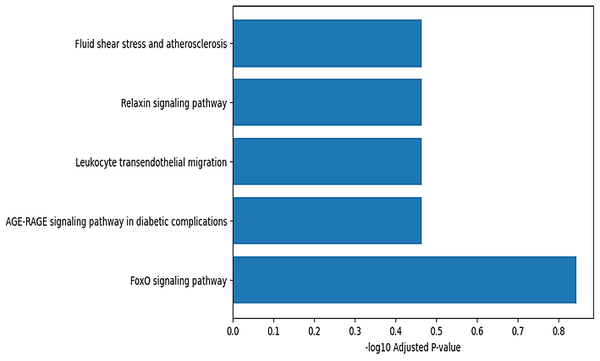
Figure 6. KEGG Pathway Enrichment Analysis
The identified pathways are linked to multiple mechanisms with biological relevance to tumour progression, immune regulation and inflammation, cellular signalling and metastatic behaviour. The FoxO signalling pathway is strongly linked with apoptosis regulation, oxidative stress response, and cancer cell proliferation, among others. Leukocyte trans endothelial migration and inflammatory signalling pathways also have strong links with tumour microenvironment interactions and immune response modulation. Even though the adjusted p-values were not as statistically significant as they could be, the pathway associations showed that the proposed framework maintains biologically meaningful gene signatures that are relevant to cancer development and progression.
5.7 Computational Performance Analysis
The processing complexity and feature dimensionality reduction ability of the proposed framework were investigated. The results obtained are summarized below in Table 4.
Table 4. Computational Characteristics of the Proposed Framework
Metric | Value
Initial Features | 20,530
Final Selected Features | 64
Dimensionality Reduction | 99.69%
Validation Strategy | Stratified 5-fold Cross-validation
Classification Model | SVM (RBF Kernel)
Stability Score | 0.664

The proposed PCFS framework resulted in significant dimensionality reduction with high classification accuracy and biological interpretability. The reduction of 20,530 genes to just 64 optimized genes greatly reduced the computational complexity and enhanced the efficiency of downstream analysis. The computational burden was moderate even with the introduction of pathway-constrained optimization and stability analysis, which makes the use of the proposed framework in the large-scale application of RNA-seq cancer classification possible.
  - Discussion
The experimental analysis confirms that the proposed PCFS framework provides effective solutions to major problems encountered with the high-dimensional classification of cancer types in RNA-seq studies, such as feature redundancy, instability in identification of the markers, and lack of biological interpretation of the markers. The combination of variance filtering, MI-based feature ranking, pathway-aware feature refinement and SVM-based classification allowed the framework to capture biologically relevant molecular information, while ensuring compact and informative gene subsets were identified. The proposed framework resulted in significant feature dimensionality reduction without significant change to the original classification performance and with computational efficiency improvements. The pathway-aware refinement strategy helped to achieve improved feature consistency by favoring selection of biologically coherent genes over statistically optimized features. This property is especially critical in the discovery of biomarkers in the genome where reproducibility and interpretation are paramount for subsequent applications in a translational space. To validate the biological relevance of the selected genes, pathway enrichment analysis was performed. The pathways identified are related to pathways of tumor progression, immune regulation, apoptosis and cellular signalling pathways that are commonly associated with tumour formation. The enrichment significance was moderate, but the pathway associations observed in the proposed framework suggest that the framework maintains biologically meaningful genomic signatures associated with cancer classification.
- Conclusion
In this study, a Pathway-Constrained Feature Selection (PCFS) framework was proposed to interpret the relationship between the features and the classes, and to classify cancer from TCGA RNA-seq datasets using features that carry biological meaning. The proposed framework overcomes the issues related to high dimensional genomic data analysis by combining variance filtering, Mutual Information based feature ranking, pathway-aware feature refinement and SVM based classification. This was an effective framework that minimized feature redundancy and maintained cancer related molecular mechanisms related information. Pathway-level information enhanced the consistency and interpretability of the gene subsets selected and preserved good classification performance. Moreover, the proposed framework exhibited computational efficiency and reproducible feature selection characteristics, making it suitable for large-scale RNA-seq cancer analysis and discovery of genome markers. Going forward, external validation on independent genomic cohorts, integration of multi-omics data, and the introduction of more sophisticated pathway graph-based optimization to enhance generalization and translation applications in precision oncology will be explored.
8. References
- Alalhareth, M., & Hong, S.-C. (2023). An improved mutual information feature selection technique for intrusion detection systems in the internet of medical things. Sensors, 23(10), 4971.
- Alkamli, S. S., & Alshamlan, H. M. (2025). Performance evaluation of hybrid Bio-Inspired and deep learning algorithms in gene selection and cancer classification. IEEE Access.
- Alweshah, M., Jebril, H., Kassaymeh, S., Almiani, M., Alkhalaileh, S., & Rjoub, G. (2026). Optimizing feature selection in cancer microarray data using a heap-driven evolutionary framework for high-dimensional spaces. Scientific Reports.
- Balasubramaniam, S., Kadry, S., TK, M. K., & Kumar, K. S. (2025). Bio-inspired Algorithms in Machine Learning and Deep Learning for Disease Detection. CRC Press.
- BreakHis. (2016). https://www.kaggle.com/datasets/ambarish/breakhis
- Chowdhury, T. M., Tabassum, F., Islam, S., & Kamal, A. R. M. (2025). A pan-cancer classification model using multi-view feature selection method and ensemble classifier. arXiv Preprint arXiv:2501.06805.
- Chen T, Kabir MF (2024) Explainable machine learning approach for cancer prediction through binarilization of RNA sequencing data. PLoS ONE 19(5): e0302947. https://doi.org/10.1371/journal.pone.0302947
- De Matos, J., Ataky, S. T. M., de Souza Britto Jr, A., Soares de Oliveira, L. E., & Lameiras Koerich, A. (2021). Machine learning methods for histopathological image analysis: A review. Electronics, 10(5), 562.
- Hasan, Y., de Lima, A., Namjoo, E., de Bulnes, D. F., Albarracín, J. F., & Ryan, C. (2025). Improving Breast Cancer Diagnosis Using Grammatical Evolution-Based Feature Selection. SN Computer Science, 6(4), 306.
- Huang, B., Tian, J., Zhang, H., Luo, Z., Qin, J., Huang, C., He, X., Luo, Y., Zhou, Y., Dan, G., & others. (2020). Deep semantic segmentation feature-based radiomics for the classification tasks in medical image analysis. IEEE Journal of Biomedical and Health Informatics, 25(7), 2655–2664.
- Ileberi, E., & Sun, Y. (2024). Machine learning-assisted cervical cancer prediction using particle swarm optimization for improved feature selection and prediction. IEEE Access, 12, 152684–152695.
- Kareem, A., Manar, A.-M., & Nafea, A. (2025). A Review of Feature Selection Techniques for Cancer Diagnosis and Prediction with Machine Learning and Deep Learning: Current Trends and Future Directions. Al-Rafid in Journal of Engineering Sciences, 343–359.
- Kaur, S., Kumar, Y., Koul, A., & Kumar Kamboj, S. (2023). A Systematic Review on Metaheuristic Optimization Techniques for Feature Selections in Disease Diagnosis: Open Issues and Challenges: S. Kaur et al. Archives of Computational Methods in Engineering, 30(3), 1863–1895.
- Kiran Suddle, M., & Bashir, M. (2026). Optimizing cancer classification: A metaheuristic-driven review of feature selection and deep learning approaches. Journal of X-Ray Science and Technology, 34(1), 103–148.
- Mehta, S., Han, F., Sohail, M., Twala, B., Ullah, A., Ullah, F., Khan, A. A., & Ling, Q. (2025). Gene selection based on adaptive neighbourhood-preserving multi-objective particle swarm optimization. Peer Computer Science, 11, e2872.
- Merceedi, K. J., & Abdulazeez, A. M. (2025). Feature Selection Methods of Gene Expression Based on Machine Learning: A Review. International Journal of Research and Applied Technology (INJURATECH), 5(1), 105–138.
- Motlagh, M. H., Jannesari, M., Aboulkheyr, H., Khosravi, P., Elemento, O., Totonchi, M., & Hajirasouliha, I. (2018). Breast cancer histopathological image classification: A deep learning approach. BioRxiv, 242818.
- Pham, H. H., Nguyen, H. Q., Nguyen, H. T., Le, L. T., & Khanh, L. (2022). An accurate and explainable deep learning system improves interobserver agreement in the interpretation of chest radiograph. IEEE Access, 10, 104512–104531.
- Piri, J., Mohapatra, P., Singh, H. K. R., Acharya, B., & Patra, T. K. (2022). An enhanced binary Mult objective hybrid filter-wrapper chimp optimization-based feature selection method for COVID-19 patient health prediction. IEEE Access, 10, 100376–100396.
- Rajakumar, G., BE, M., & Litt, D. (2022). Advance Concepts of Image Processing and Pattern Recognition.
- Ramadhani, S., Handayani, L., Ng, T., Dzulkifly, S., Ariffin, R., Budiman, H., & Wang, S. (2025). Feature Selection Optimisation for Cancer Classification Based on Evolutionary Algorithms: An Extensive Review. Computer Modelling in Engineering & Sciences, 143(3), 2711.
- Roy. (2025). Adaptive genetic algorithm based deep feature selector for cancer detection in lung histopathological images | Scientific Reports. https://www.nature.com/articles/s41598-025-86362-8
- Swathypriyadharsini, P., Rupashini, P., & Premalatha, K. (2025). Feature selection for classification based on machine learning algorithms for prostate cancer. Biomedical Physics & Engineering Express, 11(3), 035023.
- Tyagi, H., Tyagi, A. D., Garg, S., & Verma, K. (n.d.). Federated Evolutionary Feature Selection: A Framework for Scalable, Privacy-Preserving Machine Learning. Privacy-Preserving Machine Learning.
- Vijayalakshmi, S., Pandey, B. K., Pandey, D., & Lelisho, M. E. (2025). Innovative deep learning classifiers for breast cancer detection through hybrid feature extraction techniques. Scientific Reports, 15(1), 22212.
- Wang, J., Zhang, Z., & Wang, Y. (2025). Utilizing feature selection techniques for AI-driven tumor subtype classification: Enhancing precision in cancer diagnostics. Biomolecules, 15(1), 81.
- Wei, B., Han, Z., He, X., & Yin, Y. (2017). Deep learning model based breast cancer histopathological image classification. 2017 IEEE 2nd International Conference on Cloud Computing and Big Data Analysis (ICCCBDA), 348–353.
- Yan, C., Kang, X., Li, M., & Wang, J. (2021). A novel feature selection method on mutual information and improved gravitational search algorithm for high dimensional biomedical data. 2021 13th International Conference on Computer and Automation Engineering (ICCAE), 24–30.
- Yaqoob, A., Verma, N. K., Mir, M. A., Tejani, G. G., Eisa, N. H. B., Mamoun Hussien Osman, H., & Shah, M. A. (2025). SGA-Driven feature selection and random forest classification for enhanced breast cancer diagnosis: A comparative study. Scientific Reports, 15(1), 10944.
- Zhang, L., Qiao, Z., & Li, L. (2024). An evolutionary deep learning method based on improved heap-based optimization for medical image classification and diagnosis. IEEE Access, 12, 102745–102773.
- Zhao, Y., Zhang, J., Hu, D., Qu, H., Tian, Y., & Cui, X. (2022). Application of deep learning in histopathology images of breast cancer: A review. Micromachines, 13(12), 2197.

